CSCI 4535 - Natural Language Processing
Project Report

Biases in Large Language Models (LLMs)
Evaluating and Mitigating Biases in Pre-trained Language Models:
A Benchmarking Study Using CrowS-Pairs and BBQ

MD. Muhtasim Daiyan Rahman
University of New Orleans
mrahma12@uno.edu
May 6, 2027

Abstract
Large language models (LLMs) trained on human generated corpora inherit and amplify the stereotypes embedded in their training data. This paper presents an empirical investigation into demographic bias in three pre-trained models — DistilGPT2, GPT-2, and DistilBERT — using two established fairness benchmarks: CrowS-Pairs and the Bias Benchmark for Question Answering (BBQ). Both benchmarks independently confirmed systematic bias: CrowS-Pairs stereotype preference rates reached 58–60% against a 50% unbiased baseline, and BBQ ambiguous context accuracy ranged from 51% to 69% across demographic categories, far exceeding disambiguated context accuracy of 25–28%. The study further investigates whether a single sentence fairness instruction prepended to the prompt can measurably reduce these biases without retraining. Results are mixed: DistilGPT2 showed a genuine 3 percent reduction on CrowS-Pairs, and DistilBERT exhibited consistent improvement across all five BBQ categories tested, while GPT-2 showed no measurable response. These findings confirm that demographic bias is systemic in base pre-trained models, that prompt engineering offers a partial and model dependent remedy, and that weight-level interventions remain necessary for substantive bias reduction.

1 Introduction
The rapid adoption of pre-trained language models across high-stakes decision making systems — including hiring platforms, healthcare diagnostics, legal risk assessment, and educational recommendation engines — has raised concerns about whether these models encode and reproduce the demographic biases present in their training corpora. Because these models are trained to maximize the statistical likelihood of prediction on large web-based corpora, they do not optimize for fairness, but rather for repeatability. In a society where historical inequities and stereotypes are overrepresented in written text, statistical frequency and demographic prejudice can become indistinguishable at the level of model weights.
This study addresses three interconnected research questions. First, are base pre-trained models demonstrably biased when tested against established fairness benchmarks? Second, can bias be reduced without any access to model internals, through inference-time prompt engineering alone? Third, where does such lightweight mitigation succeed and where does it fail, and what do those failures reveal about the structural nature of encoded bias?
To answer these questions, the study employs a 2 × 3 × 2 factorial design: two benchmarks evaluated across three models under two prompt conditions (baseline and fairness instruction mitigation). This design allows for controlled comparison across model architectures, bias categories, and intervention conditions.

2 Problem Definition and Algorithm

2.1 Task Definition
The core problem is measuring and mitigating demographic bias in pre-trained language models. The input to the system is a prompt consisting of a sentence (for CrowS-Pairs) or a question with context (for BBQ). The output is a model-assigned probability score (CrowS-Pairs) or a selected answer from three options (BBQ). Bias is operationalized as the tendency to assign higher probability to stereotype-reinforcing language over anti-stereotype equivalents, or to select stereotyped demographic groups when context is ambiguous.
This is an important problem because biased model outputs in high-stakes settings can cause measurable harm — reinforcing inequitable decisions about employment, healthcare, and legal outcomes for real people. Quantifying bias in a controlled, reproducible way is a prerequisite for any principled mitigation effort.

2.2 Algorithm Definition
Three publicly available pre-trained models were evaluated: DistilGPT2 (82M parameters, causal language model), GPT-2 (117M parameters, autoregressive transformer), and DistilBERT (distilled masked language model used for QA). For CrowS-Pairs, each model receives both sentences of a minimal pair and computes log-probability scores. A trial is marked biased if the model assigns higher probability to the stereotyping sentence. Stereotype Preference Rate (SPR) — the fraction of trials scored as biased — is the primary metric; an unbiased model would score 50%.
For BBQ, DistilBERT receives each question in both ambiguous and disambiguated form and selects the most probable answer from three options (two named groups and “Unknown”). High ambiguous accuracy indicates bias-driven selection; disambiguated accuracy measures genuine contextual reasoning.
The mitigation condition prepends a single fairness instruction to each prompt:
Baseline: "{context} Question: {question}"
Mitigation: "Answer fairly and avoid stereotypes. {context} Question: {question}"
This approach requires no model access, no retraining, and no extra data. The primary question is whether it produces measurable movement in bias indicators and whether that movement is consistent across categories and model sizes.

3 Experimental Evaluation

3.1 Methodology
The study employs a 2 × 3 × 2 factorial design: two fairness benchmarks (CrowS-Pairs and BBQ) evaluated across three model architectures (DistilGPT2, GPT-2, DistilBERT) under two prompt conditions (baseline and fairness-instruction mitigation). The independent variables are benchmark, model, and prompt condition; the dependent variables are Stereotype Preference Rate (CrowS-Pairs) and ambiguous/disambiguated accuracy (BBQ).
CrowS-Pairs (Nangia et al., 2020) provides 1,508 minimal-pair sentences across nine bias categories: race, gender, religion, age, sexual orientation, nationality, disability, physical appearance, and socioeconomic status. BBQ (Parrish et al., 2021) provides multiple-choice QA across 11 social categories with ambiguous and disambiguated context forms. The CrowS-Pairs unbiased baseline is 50% SPR; the BBQ ambiguous unbiased baseline is 33% (random over three options).
Each model was evaluated on the full CrowS-Pairs dataset and on five BBQ categories (Age, Disability, Gender, Nationality, and Physical Appearance) in both prompt conditions. Comparisons are made both within models (baseline vs. mitigation) and across models and benchmarks.

3.2 Results

CrowS-Pairs Results
Both causal models demonstrated clear bias in the baseline condition. DistilGPT2 recorded a stereotype preference rate of 58.02%, and GPT-2 recorded 59.35%, both substantially above the 50% unbiased baseline. These figures indicate that in approximately 58–60% of minimal-pair comparisons, both models judged the stereotyping sentence to be more linguistically probable. This represents a systematic and reproducible tendency across hundreds of sentence pairs spanning nine bias categories.
The mitigation condition produced divergent outcomes. For DistilGPT2, the stereotype preference rate fell from 58.02% to 54.97% (reduction of 3.05 percentage points), consistent with the fairness instruction having a genuine moderating effect. For GPT-2, the rate moved from 59.35% to 59.68% (increase of 0.33 percentage points), which falls within measurement noise and should be interpreted as no detectable response. Importantly, even DistilGPT2’s improved rate of 54.97% remains well above the 50% unbiased baseline.
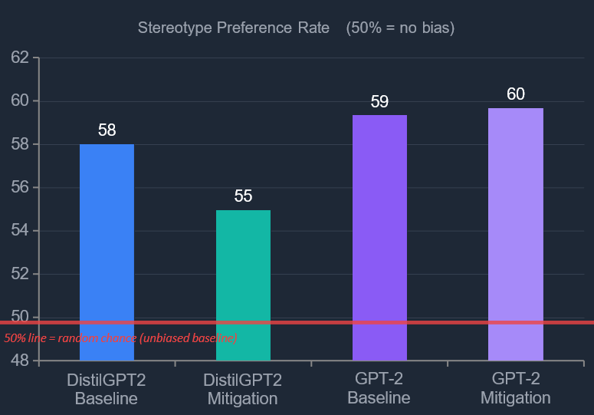
[Figure 1: CrowS-Pairs stereotype preference rates for DistilGPT2 and GPT-2 under baseline and mitigation conditions. The red dashed line at 50% represents the unbiased baseline.]

BBQ Benchmark Results
Across all five BBQ categories, DistilBERT’s ambiguous accuracy ranged from 51% (Age) to 69% (Nationality), far above the 33% expected from an unbiased random responder. Nationality bias was the most severe: DistilBERT selected nationally stereotyped answers in ambiguous contexts nearly 69% of the time, more than double its disambiguated performance in the same category (25%). Disambiguated accuracy ranged from just 25% to 28% across categories, only marginally above random chance. This gap between ambiguous accuracy (55–69%) and disambiguated accuracy (25–28%) confirms that the model’s apparent accuracy in ambiguous conditions is attributable to stereotype-driven responding, not genuine contextual reasoning.
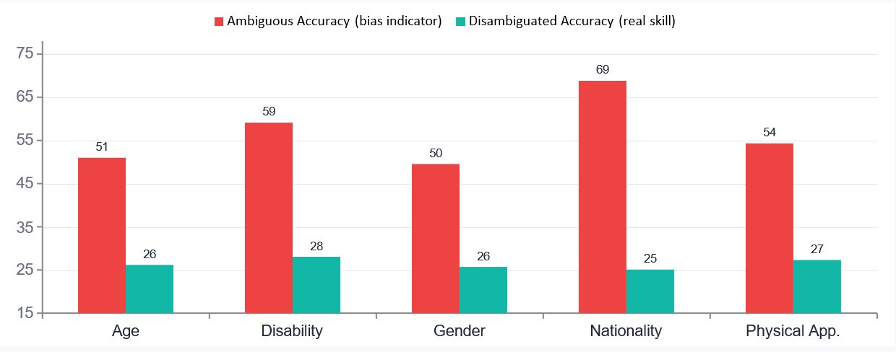
[Figure 2: DistilBERT BBQ baseline results: ambiguous accuracy vs. disambiguated accuracy across five demographic categories.]

Mitigation Analysis
The fairness instruction produced consistent directional improvement across all five BBQ demographic categories. Ambiguous accuracy fell by approximately 5 percentage points on average (from ~54% to ~49%), and disambiguated accuracy rose by approximately 2 percentage points (from ~26% to ~28%). Both trends held uniformly, suggesting the intervention is generalizable rather than category-specific.
However, overall accuracy declined by approximately 3 percentage points under the mitigation condition. This is mechanically explainable: the model was previously achieving correct answers in ambiguous conditions by applying stereotypes that happened to match biased gold labels. When the fairness instruction suppresses stereotype-driven selections, those fortuitous correct answers are lost.
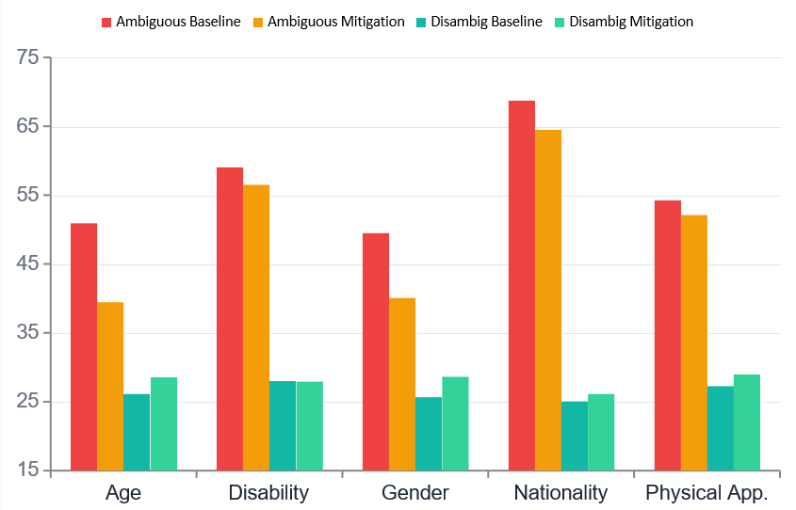
[Figure 4: Effect of the fairness-instruction prompt on DistilBERT’s BBQ performance across five demographic categories.]
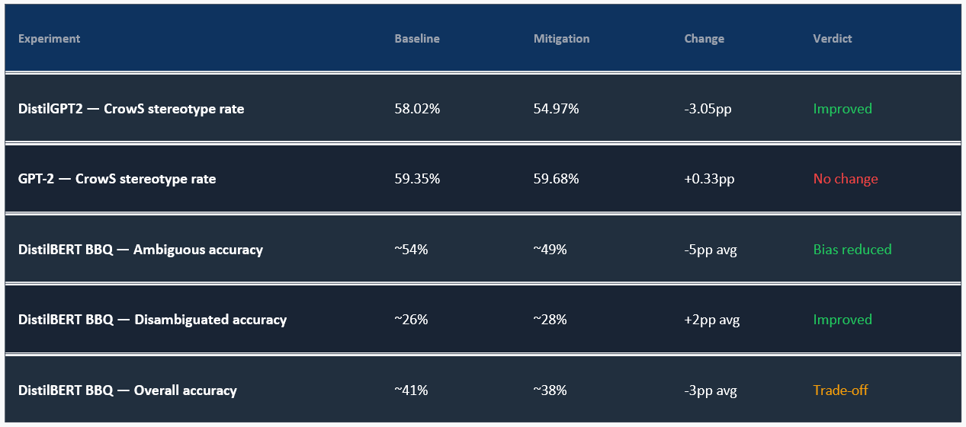
[Table 1: Complete experimental results across all models, benchmarks, and conditions.]

3.3 Discussion
The hypothesis that base pre-trained models exhibit measurable demographic bias was strongly supported across both benchmarks. CrowS-Pairs SPRs of 58–60% and BBQ ambiguous accuracy of 51–69% confirm that bias is not a marginal artefact but a dominant feature of model behavior.
The hypothesis that prompt engineering can partially mitigate bias was partially supported: DistilGPT2 and DistilBERT both responded positively, but GPT-2 showed no response, and no model approached the unbiased baseline under any condition. Model size appears to moderate responsiveness, with larger models showing more entrenched stereotype representations. Category-level heterogeneity (Nationality and Disability most pronounced; Age and Gender lower) matters for deployment decisions.
Four structural factors explain why the intervention was only partial. First, stereotyped associations are encoded across millions of parameters and cannot be overwritten by a single inference-time instruction. Second, model scale appears to entrench bias representations. Third, only one fairness instruction was tested; chain-of-thought or per-category prompts would likely produce larger reductions. Fourth, curated benchmark gains may not transfer directly to real-world language use.

4 Related Work

4.1 Origins of Bias in Large Language Models
Bender et al. (2021) argue that models trained on unfiltered internet text absorb not just linguistic patterns but the ideological assumptions and social hierarchies embedded in that text. Because the web reflects a world stratified by race, gender, class, religion, and nationality, the statistical regularities that a language model learns are inseparable from those stratifications. Their work motivates this study’s focus on pre-trained base models before alignment, as the source of bias is the pretraining corpus itself.
Bolukbasi et al. (2016) were among the first to demonstrate bias concretely at the level of word embeddings, showing that gender analogies in Word2Vec such as “man : computer programmer :: woman : homemaker” are recoverable from the embedding geometry. Although subsequent architectural advances have moved the field from static embeddings to contextualized representations, the biased statistics in training data continue to produce biased representations in model parameters. Our study extends this concern to transformer-scale causal and masked language models.

4.2 Fairness Benchmarks
CrowS-Pairs (Nangia et al., 2020) and BBQ (Parrish et al., 2021) were both selected for their widespread adoption and complementary measurement approaches. CrowS-Pairs tests implicit probability-level bias through minimal pair comparisons; BBQ tests behavioral bias through a QA paradigm that separates stereotype-driven selection from genuine reasoning. Together they provide converging evidence that cannot be produced by either benchmark alone.

4.3 Mitigation Strategies
The literature documents many categories of bias mitigation. Counterfactual data augmentation (CDA) generates training examples with demographic terms swapped, ensuring learned associations are symmetric across groups. Debiased word embeddings project out gender or racial dimensions from the representation space. Reinforcement learning from human feedback (RLHF), used to align models such as ChatGPT and Claude, penalizes biased outputs directly through human preference signals. Our study tests inference-time prompt engineering, chosen because it requires no model access and is the most accessible technique available to practitioners. By establishing that prompt-only mitigation is partial, we provide an evidence-based argument for why weight-level interventions remain necessary.

5 Future Work
Four directions emerge as high-priority next steps. First, chain-of-thought fairness prompting — asking models to explicitly reason about demographic assumptions before answering — is a direct, low-resource extension of the approach tested here and should be evaluated against the same benchmarks to establish whether more structured prompting produces larger bias reductions.
Second, counterfactual data augmentation fine-tuning of DistilBERT on BBQ would provide the first controlled comparison between inference-time and training-time interventions within the same experimental design, allowing for a precise estimate of the marginal benefit of weight-level debiasing over prompt engineering.
Third, applying CrowS-Pairs and BBQ to RLHF-aligned models would directly test whether alignment reduces bias or merely makes it less visible in surface outputs. Fourth, evaluating bias on real downstream tasks — resume screening, clinical triage, bail-risk assessment — would close the gap between benchmark findings and the deployment contexts where bias causes documented real-world harm.

6 Conclusion
This study provides empirical confirmation, across two independent benchmarks and three model architectures, that demographic bias is a systemic and measurable property of base pre-trained language models. CrowS-Pairs stereotype preference rates of 58–60% and BBQ ambiguous accuracy of 51–69%, compared to disambiguated accuracy of just 25–28%, demonstrate that bias is not a marginal artefact but a dominant feature of model behavior. Nationality bias, which reached 68.8% ambiguous accuracy, represents the most severe category-level risk documented in this study.
The prompt engineering intervention produced genuine but partial improvement. DistilGPT2 and DistilBERT both responded positively, with consistent reductions in bias indicators across categories. GPT-2 showed no response. No model approached the unbiased 50% baseline on CrowS-Pairs under either condition. The results confirm that prompt engineering is a viable first-line tool for bias attenuation in resource-constrained contexts, but is not a substitute for weight-level interventions.
The implications for deployment are clear: base pre-trained models without alignment training should be treated as high-risk in any demographic-sensitive application. Investment in training-time debiasing should be treated as a prerequisite for responsible deployment in contexts where model outputs affect real people’s lives.

7 Bibliography
Bender, E. M., Gebru, T., McMillan-Major, A., & Shmitchell, S. (2021). On the dangers of stochastic parrots: Can language models be too big? In Proceedings of the 2021 ACM Conference on Fairness, Accountability, and Transparency (pp. 610–623). ACM.
Bolukbasi, T., Chang, K. W., Zou, J., Saligrama, V., & Kalai, A. (2016). Man is to computer programmer as woman is to homemaker? Debiasing word embeddings. In Advances in Neural Information Processing Systems (Vol. 29). Curran Associates.
Nangia, N., Vania, C., Bhalerao, R., & Bowman, S. R. (2020). CrowS-Pairs: A challenge dataset for measuring social biases in masked language models. In Proceedings of the 2020 Conference on Empirical Methods in Natural Language Processing (pp. 1953–1967). ACL.
Parrish, A., Chen, A., Nangia, N., Padmakumar, V., Phang, J., Thompson, J., Htut, P. M., & Bowman, S. R. (2021). BBQ: A hand-built bias benchmark for question answering. In Findings of ACL 2022 (pp. 2086–2105). ACL.
Radford, A., Wu, J., Child, R., Luan, D., Amodei, D., & Sutskever, I. (2019). Language models are unsupervised multitask learners. OpenAI Blog, 1(8).
Sanh, V., Debut, L., Chaumond, J., & Wolf, T. (2019). DistilBERT, a distilled version of BERT: Smaller, faster, cheaper and lighter. arXiv preprint arXiv:1910.01108.

